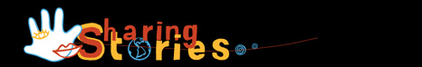Outline Map of Australia BLM

© 2013 Sharing Stories Pty Ltd (except where otherwise indicated). This material may be used (but not modified), reproduced, published, and communicated free of charge for non-commercial educational purposes until 31 December 2018, provided all copyright notices and acknowledgements are retained. Resources written by Alwyn Evans and Liz Thompson.

