Identity and the Stolen Generation BLM
Discuss this topic with your class, and ask students to begin a personal, or develop a class, KWL chart (What I know/What I’d like to find out about/What I’ve learned). Students may research ‘Stolen Generation’, to answer their questions. These two women talk about their feelings in coming to terms with their identity.
Aunty Trish Vines |  | Wiradjuri | Culture & Community

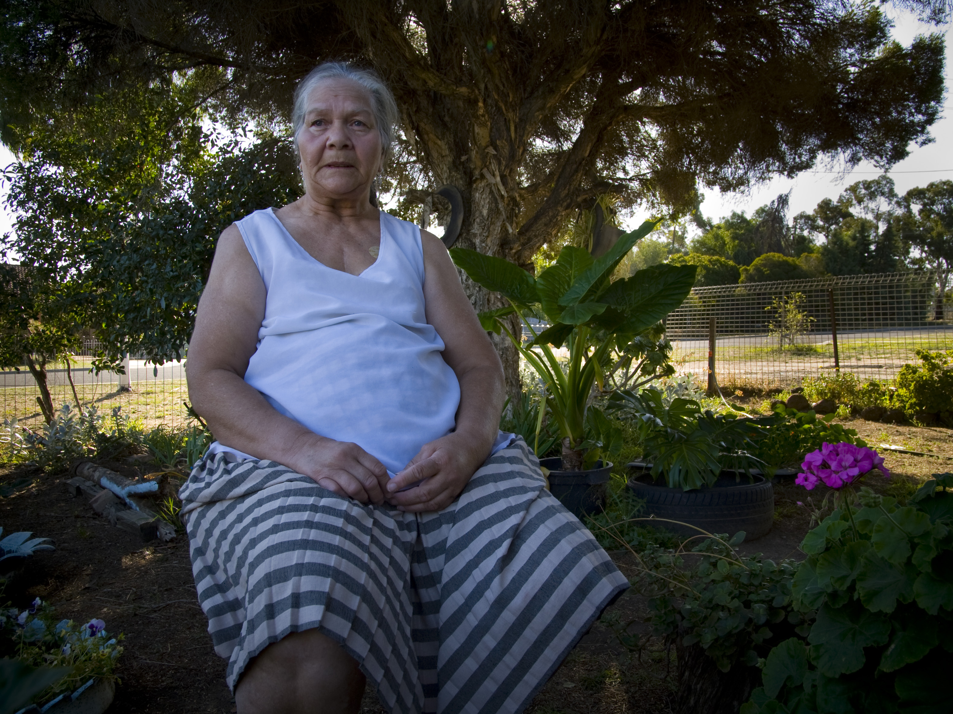
I’m Wiradjuri from New South Wales. I grew up with a white Scottish father and an Aboriginal mum that had Spanish and German running through her blood. I didn’t know who I was, where I was going, what I was doing or going to do—it was very confusing.
I didn’t have the black skin like my mum and I was very wild. I would have loved to have been like that. My older sisters were taken away (stolen generations) and there was a wall there between me and them. We finally got through that, but it hurt because people were taken away from us and the Culture or traditions can’t be handed down. When you lose that, you lose everything; you’re just like a ship on the sea without a captain.That’s how a lot of Koori kids are, drifting through life. It hurts not to know where you really actually fit in. When you do eventually find your identity, it’s like walking out of a dark room into a beautiful room that’s full of everything and it’s part of you. That’s how it feels to me, and I get really emotional with it.
© 2013 Sharing Stories Pty Ltd (except where otherwise indicated). This material may be used (but not modified), reproduced, published, and communicated free of charge for non-commercial educational purposes until 31 December 2018, provided all copyright notices and acknowledgements are retained. Resources written by Alwyn Evans and Liz Thompson.
Aunty Lynne Warren |  | Yorta Yorta  Wemba Wemba | Culture & Community

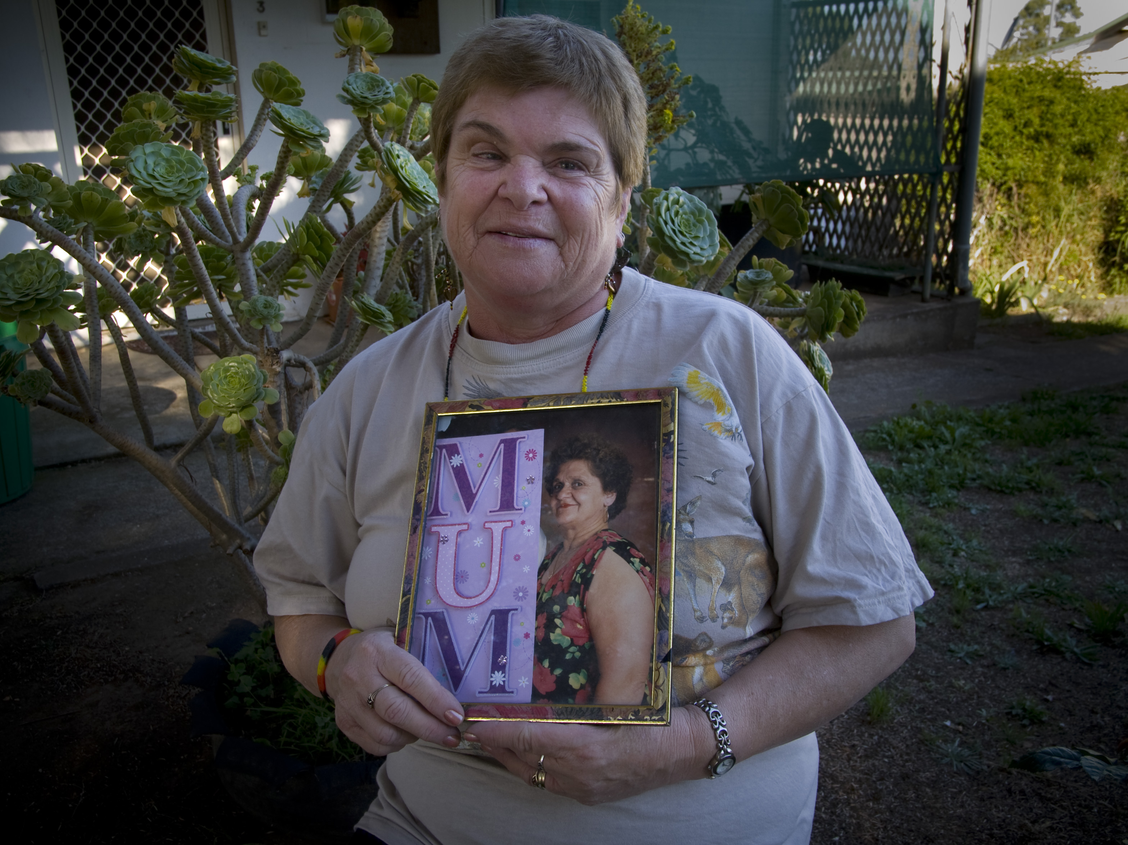
For those looking at the picture of me you would think I was a white person, but my father was white and my mother Aboriginal. I was classed as quarter-caste. I grew up with my grandmother, and only after Mum died was I told who she was and that she was Aboriginal.
I’d always thought I was a white person. It never crossed my mind there was anything different until I heard about Mum. Part of me was excited, part of me was angry; I had so many mixed emotions.
I wanted to find out as much as I could about Culture and history and family then. I love hearing the Elders’ stories. I thought the story Uncle Brien told us was really terrific. It’s very inspirational and really great for our young kids to learn about their history, that Bunjil was our Creator spirit.
If they don’t hear the stories now and have them recorded, when they grow up they’ll have nothing to look around and say what happened. When their children grow up, they got no answers for them; there’s just a big hole, there’s nothing there. It’s important to keep the stories going to hold it all together.
See details in the Background Information for Teachers section.

© 2013 Sharing Stories Pty Ltd (except where otherwise indicated). This material may be used (but not modified), reproduced, published, and communicated free of charge for non-commercial educational purposes until 31 December 2018, provided all copyright notices and acknowledgements are retained.
Resources written by Alwyn Evans and Liz Thompson.

